

Business Question and Visualisation Report
Date | 19 October 2026
Team ID | Roll 58
Project Name | ev_market_train project
Maximum Marks | 5 Marks

Visualization development refers to the process of creating graphical representations of data to facilitate understanding, analysis, and decision-making. The goal is to transform complex datasets into visual formats that are easy to interpret, enabling users to gain insights and make informed decisions. Visualization development involves selecting appropriate visual elements, designing layouts, and using interactive features to enhance the user experience. This process is commonly associated with data visualization tools and platforms, and it plays a crucial role in business intelligence, analytics, and reporting
Business Questions and Visualisation
The process involves defining specific business questions to guide the creation of meaningful and actionable visualizations using data stored in Snowflake. Well-framed business questions help identify the required metrics, determine the appropriate Snowflake tables or analytical views, select relevant data, and create visualizations that provide useful business insights.
1. Annual Sales by Manufacturer
Business question: Which manufacturers have the highest recorded annual sales?
- Code: SELECT
MANUFACTURER,
SUM(ANNUAL_SALES_UNITS) AS TOTAL_ANNUAL_SALES
FROM EV_MARKET_TRAIN
GROUP BY MANUFACTURER
ORDER BY TOTAL_ANNUAL_SALES DESC
LIMIT 10;
- Screenshot of visualisation:

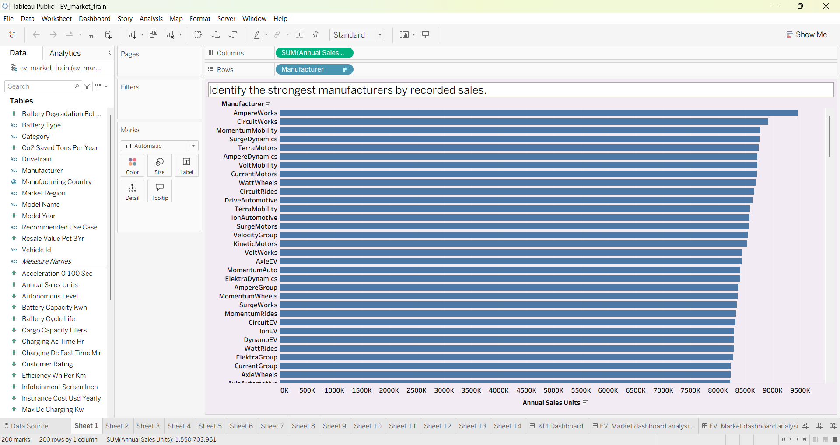
Visualization: Horizontal bar chart — manufacturer vs. total annual sales.
2. Sales by Vehicle Category
Business question: Which vehicle categories have the highest recorded annual sales?
- Code: SELECT
CATEGORY,
SUM(ANNUAL_SALES_UNITS) AS TOTAL_ANNUAL_SALES
FROM EV_MARKET_TRAIN
GROUP BY CATEGORY
ORDER BY TOTAL_ANNUAL_SALES DESC;

- Screenshot of visualisation:
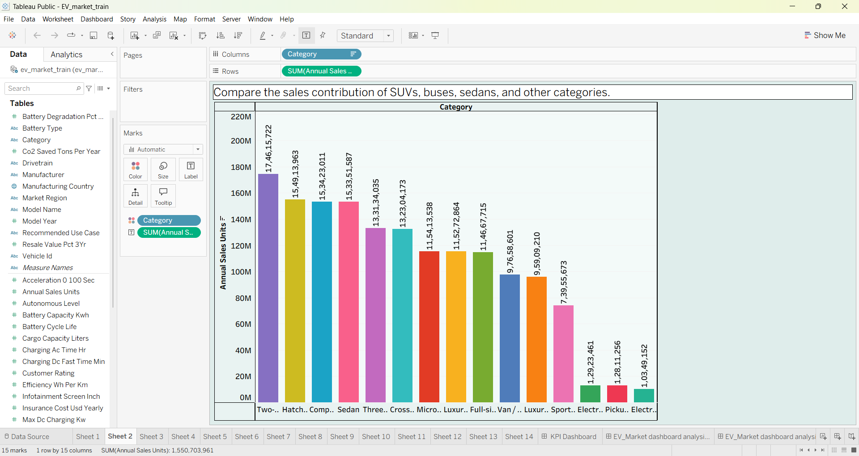
Visualization: Bar chart — vehicle category vs. total annual sales.

3. Battery Technology Distribution
Business question: Which battery technology is most common among the recorded vehicles?
- Code: SELECT
BATTERY_TYPE,
COUNT(DISTINCT VEHICLE_ID) AS VEHICLE_COUNT
FROM EV_MARKET_TRAIN
GROUP BY BATTERY_TYPE
ORDER BY VEHICLE_COUNT DESC;
- Screenshot of visualisation:
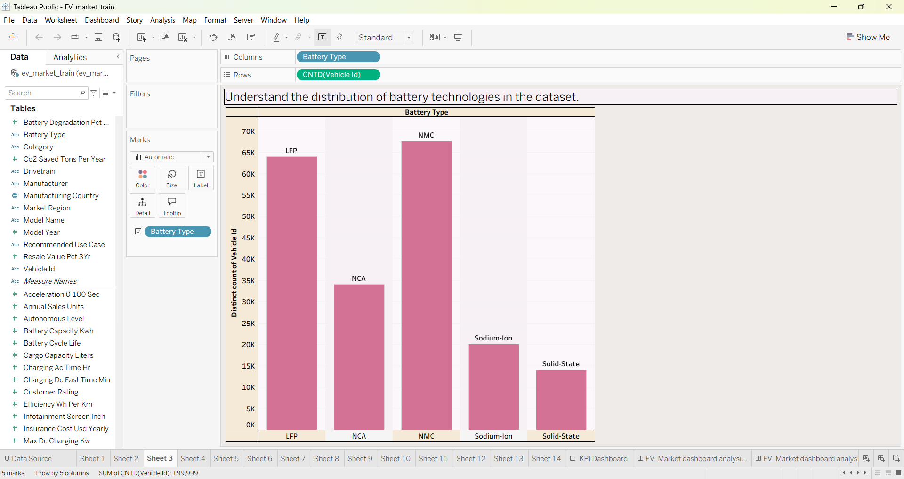

Visualization: Bar chart — battery type vs. distinct vehicle count
4. Average Driving Range by Category
Business question: Which vehicle category has the highest average driving range?
- Code: SELECT
CATEGORY,
ROUND(AVG(RANGE_KM), 2) AS AVG_DRIVING_RANGE_KM
FROM EV_MARKET_TRAIN
GROUP BY CATEGORY
ORDER BY AVG_DRIVING_RANGE_KM DESC;
- Screenshot of visualisation:

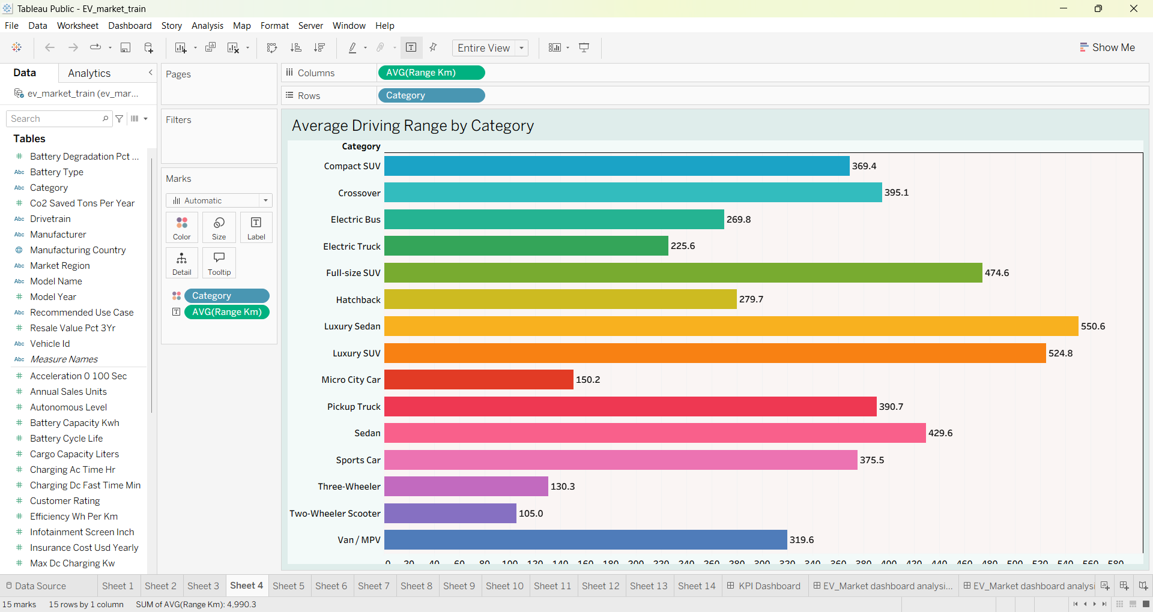

Visualization: Bar chart — vehicle category vs. average driving range in kilometres.

5. Price vs. Driving Range
Business question: What is the relationship between EV price and driving range?
- Code: SELECT
VEHICLE_ID,
MODEL_NAME,
CATEGORY,
PRICE_USD,
RANGE_KM
FROM EV_MARKET_TRAIN
WHERE PRICE_USD IS NOT NULL
AND RANGE_KM IS NOT NULL
ORDER BY PRICE_USD
LIMIT 5000;
- Screenshot of visualisation:

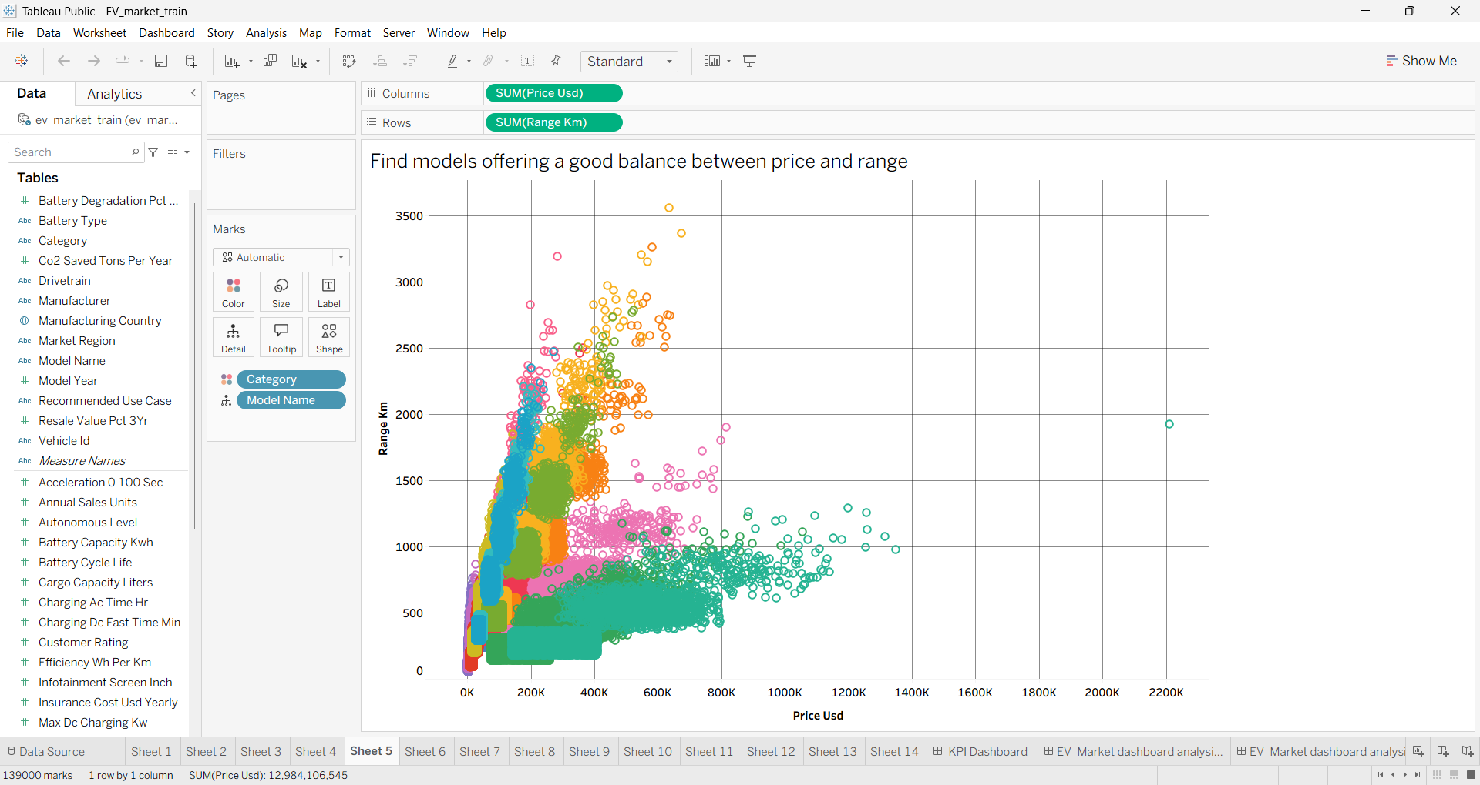
Visualization: Scatter plot — price on the X-axis, driving range on the Y-axis, and vehicle category as the colour.
This query returns individual vehicle records so you can explore the relationship rather than aggregating the data into category averages.

6. Customer Rating by Manufacturer
Business question: Which manufacturers have the highest average customer ratings?
- Code: SELECT
MANUFACTURER,
ROUND(AVG(CUSTOMER_RATING), 2) AS AVG_CUSTOMER_RATING,
COUNT(CUSTOMER_RATING) AS RATING_COUNT
FROM EV_MARKET_TRAIN
GROUP BY MANUFACTURER
HAVING COUNT(CUSTOMER_RATING) > 0
ORDER BY AVG_CUSTOMER_RATING DESC
LIMIT 10;
- Screenshot of visualisation:

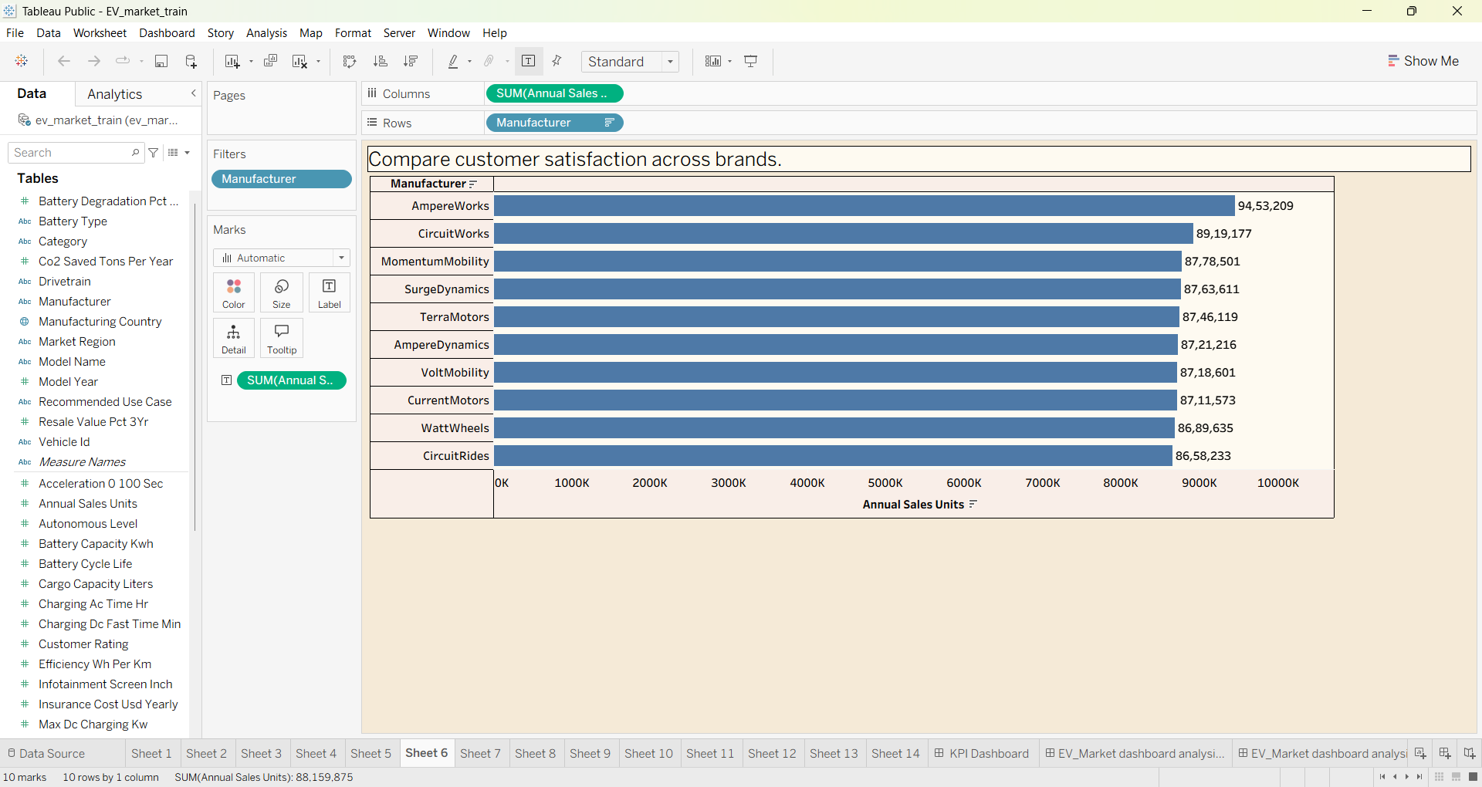
Visualization: Horizontal bar chart — manufacturer vs. average customer rating. The RATING_COUNT column helps you understand how many ratings contribute to each average.

7. EV Manufacturing by Country
Business question: Which manufacturing countries have the highest number of recorded vehicles?
- Code: SELECT
MANUFACTURING_COUNTRY,
COUNT(DISTINCT VEHICLE_ID) AS VEHICLE_COUNT
FROM EV_MARKET_TRAIN
GROUP BY MANUFACTURING_COUNTRY
ORDER BY VEHICLE_COUNT DESC
LIMIT 15;
- Screenshot of visualisation:
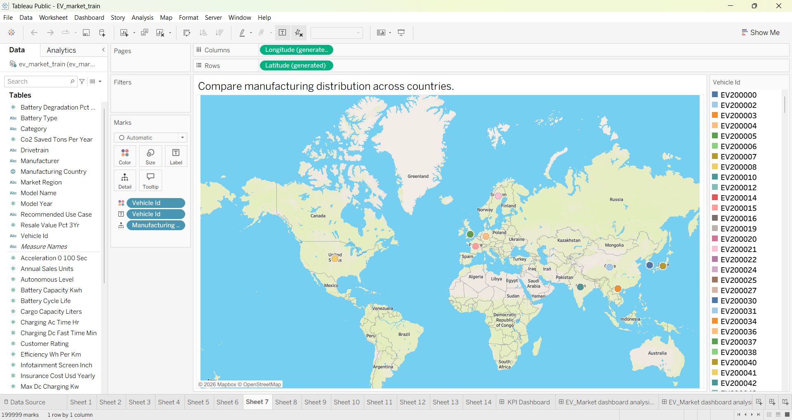
Visualization: Horizontal bar chart or map — manufacturing country vs. distinct vehicle count.

8. Sales by Model Year
Business question: How do recorded annual sales vary by vehicle model year?
- Code: SELECT
MODEL_YEAR,
SUM(ANNUAL_SALES_UNITS) AS TOTAL_ANNUAL_SALES
FROM EV_MARKET_TRAIN
WHERE MODEL_YEAR IS NOT NULL
GROUP BY MODEL_YEAR
ORDER BY MODEL_YEAR;
- Screenshot of visualisation:

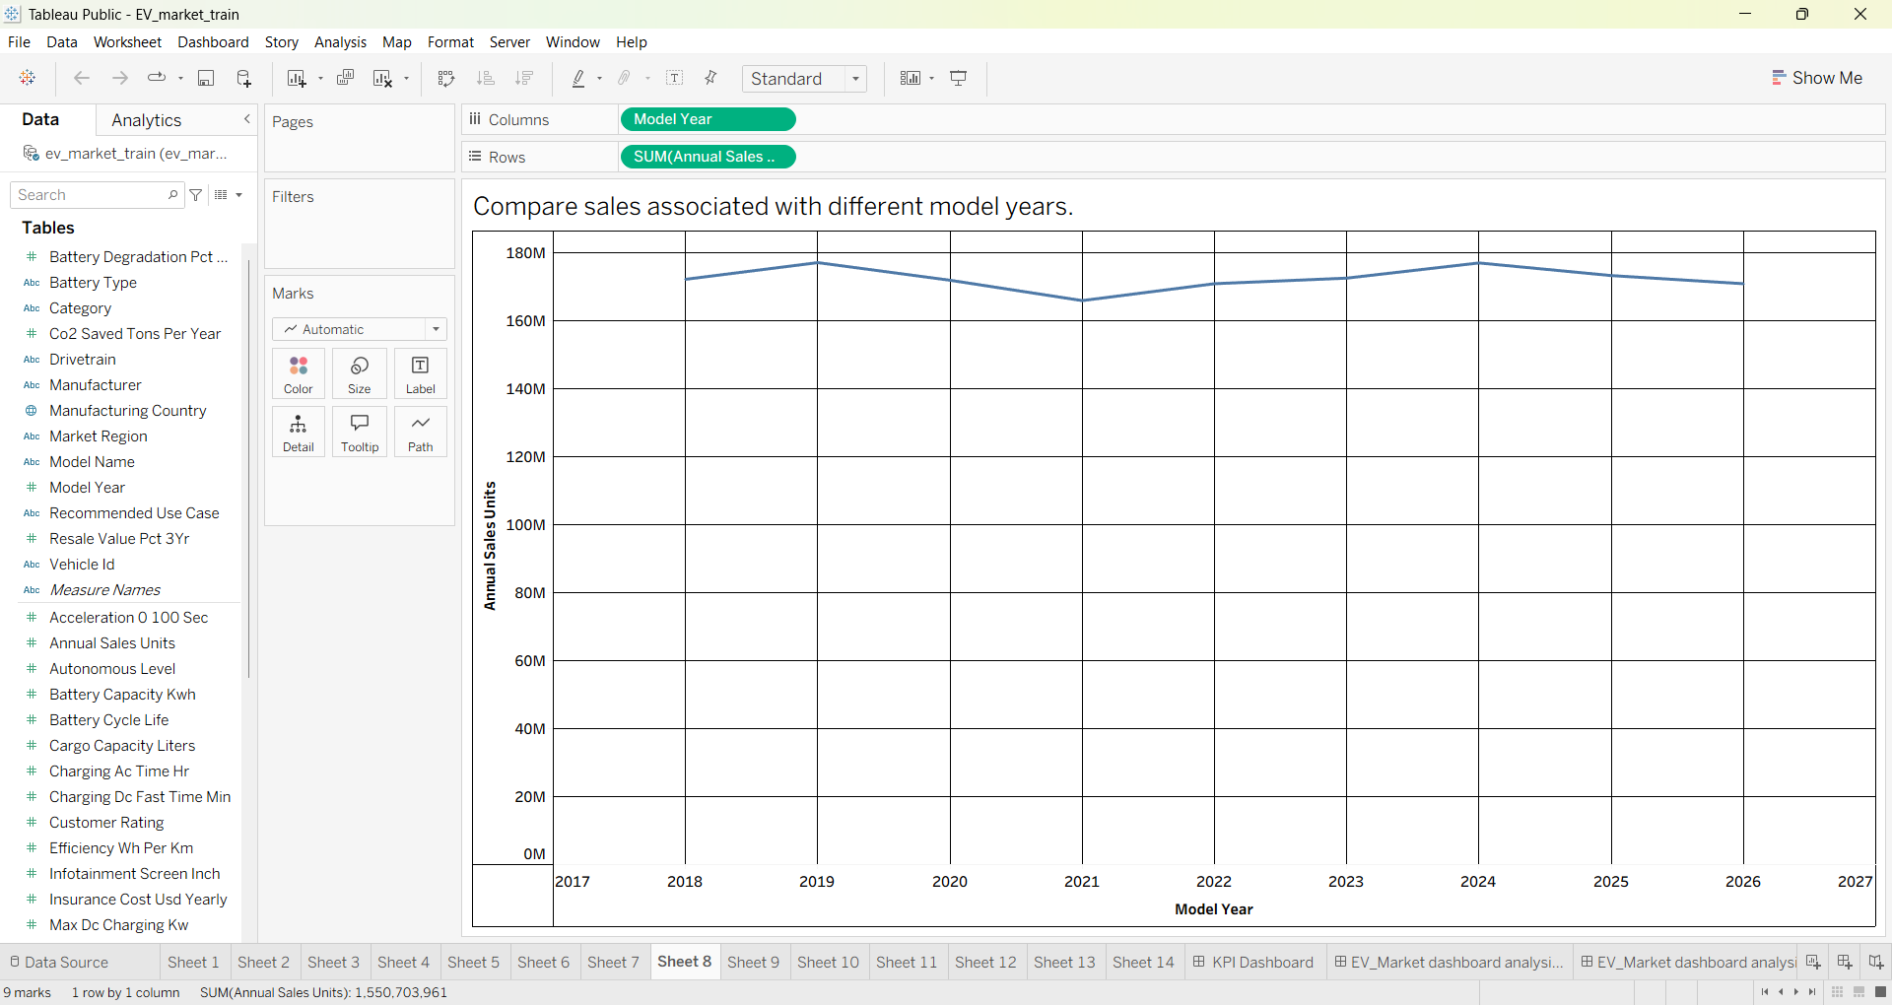

Visualization: Line chart — model year on the X-axis and total recorded annual sales on the Y-axis.
Note that MODEL_YEAR is the vehicle's model year, not necessarily the calendar date when sales occurred.

